NAJUA 2016 Nominations Vita Form

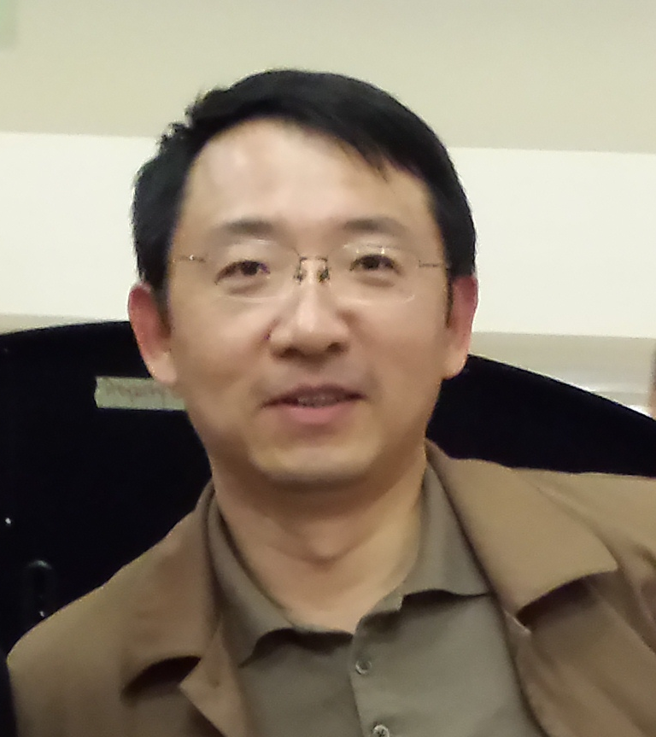 | Nominee Name: Dr. Yuan Yao  Position for Nominee: BOD

Experience (indicate professional, community, and university experience):
Over 20 years of food and food ingredients industrial and academic experiences, including over 10 years of professorship at Purdue University’s Food Science Department.

Served as grant review panelist, symposium chair, national workshop organizer, award judge, etc., in numerous professional occasions.

Education (indicate institutions, degrees, year, and major fields):
2000, Ph.D. Food Science, Jiangnan University
1992, MS, Chemical Engineering, Dalian University of Technology
1989, BS, Polymer Science, Dalian University of Technology

Statement (Vision and Ideas regarding the position nominated with NAJUA):
Lead the organization to fulfill NAJUA’s Vision and Mission. Pursue additional benefits for the members, while continue with the organization’s tradition in the professional and academic areas. Contribute to NAJUA and its members’ career and life success.

I have discussed the responsibilities of the position with a Nominating Committee member so that I am fully informed of its responsibilities.

8Nominee: Yuan Yao 07/05/2016
Signature Date

